EXERCISE: 8
DATE: 23.11.2020

AIM:
To write a Python program to get a list of numbers of list and create a list of tuples having first element as the number and second element as the cube of the number.
PROGRAM:
n = int(input())
lst = []
for i in range(n):
a = int(input())
lst.append(a)
r = [(j,pow(j,3)) for j in lst]
print(r)
def first(n):
return n[0]
r.sort(key = first)
print(r)
LINK:
http://103.53.53.18/mod/vpl/forms/submissionview.php?id=317&userid=1757
OUTPUT:
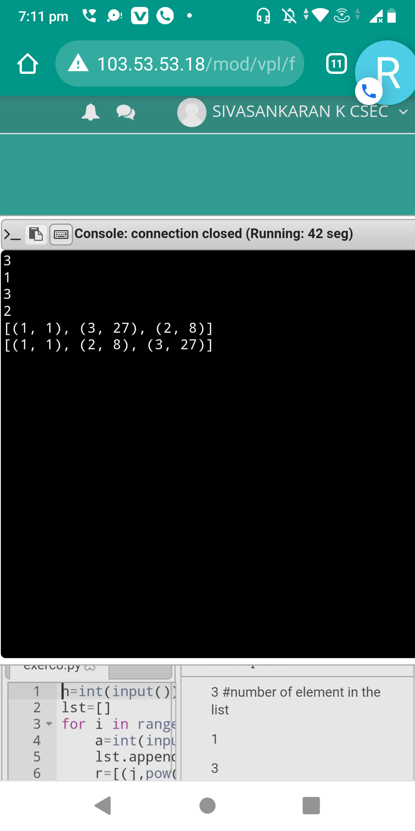
RESULT:
The output for the above program is successfully obtained.

